# 

# **Department of Computer Science and Engineering Islamic University of Technology (IUT)** A subsidiary organ of OIC

# **Laboratory Report**

# CSE 4412: Data Communication and Networking Lab

## 

|  |  |
| --- | --- |
| **Name** | **: Chowdhury Ashfaq** |
| **Student ID** | **: 200042123** |
| **Section** | **: A** |
| **Semester** | **: 4th** |
| **Academic Year** | **: 2022** |
| **Date of Submission** | **: 04/02/2023** |
| **Lab No** | **: 05** |

### **Title:** Router Configuration and using static routing to connect multiple LANs in CISCO Packet Tracer.

### **Objective**:

1. Understand Default Gateway
2. Difference between Switch and Router.
3. Router to Router Wiring [Using DCE and DTE Cables]
4. Static Routing Configuration
5. Default Route

### **Devices/ software Used**:

1. Cisco Packet Tracer
2. PC
3. 2960-24TT Switch
4. Router
5. Server

### **Diagram of the experiment:**

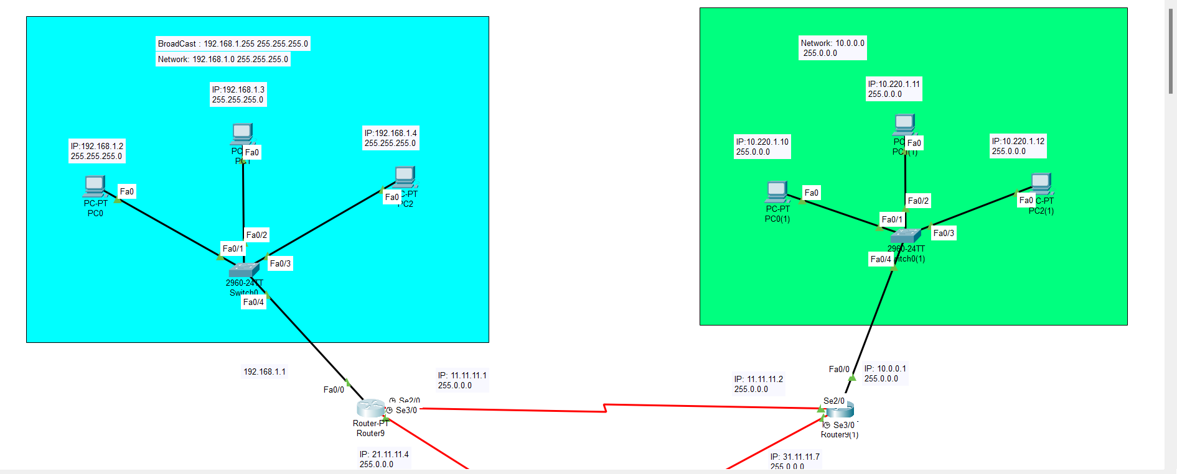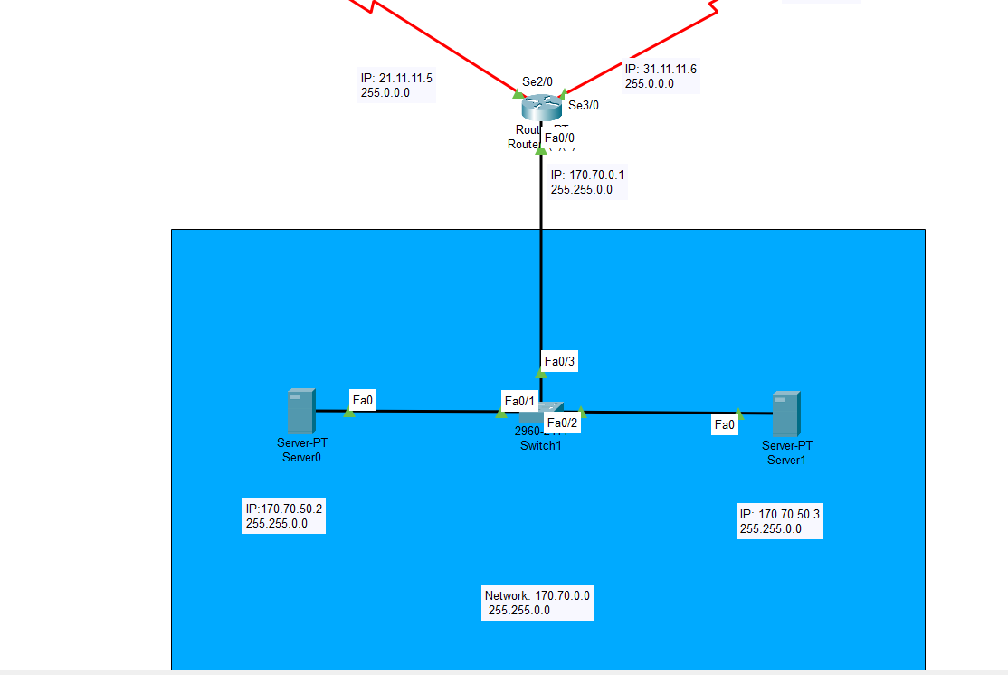

### **Theory:**

**Default Gateway:** (If it is not set what may happen?)

A default gateway is the path a node will follow when it doesn’t know where the destination is. If default gateway is not set then the devices in the network won’t be able to access other networks.

**Difference between Switch and Router**

Router is layer 3 device and switch is layer 2 device.

Router connects various networks but switch connects device of same network.

**Router to Router Wiring [Using DCE and DTE Cables]**

DCE/DTE cables are used to connect two routers. On one end of the cable we set the clock-speed at which the data can be passed. On the other end the clock-speed is set automatically.

**Static Route**

The routes that are set manually or statically in the router interface are static routes. These networks are not directly connected with the router. There’s command to set static route and insert it on routing table.

**Default Route**

Default route is address of another router. When one packet is sent through the router then if the route matches it is forwarded or the packet is sent to the default route. If default route is not available then the packet is dropped.

### **Configuration of Routers:**

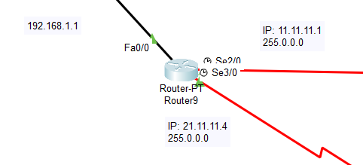

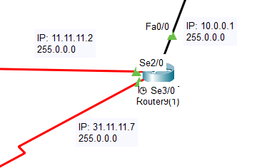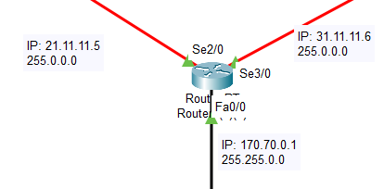

### **Observation:**

1. Switch can’t connect two devices of different network. We need router to do that.
2. Each interface in a router will have different IP address.
3. First valid host address will be the IP address of the interface/port.
4. Routing can be set in two ways: Port address and IP address.
5. On one part of DCE/DTE cable clock-speed is set other part just follows it.
6. Message from one device of a network can be sent to another device of another network only if there’s a route defined in the routing table.

### **Challenges:**

### Configuring the IP address according to ports.

1. The Command for different actions like adding static route.